Exercise (Instructions): MyBlogApp

Objectives and Outcomes

In this exercise you will create a MyBlogApp

* Create a new Angular Project
* Create component Blog
* Use Services

Create a new Angular Project

* Choose a directory, under the cmd, add the following code

1. ng new MyBlogApp

2. cd MyBlogApp

Create a new Service

* Under folder app; create a new folder, name it “***services***”
* Under services, create a new file “post.service.ts”

import {Injectable} from '@angular/core';

@Injectable()

export class PostService{

    getPosts(){

        return POSTS;

    }

}

export const POSTS = [

    {id : 1, title: "Post One", body:"This is Post ONE"},

    {id : 2, title: "Post Two", body:"This is Post TWO"},

    {id : 3, title: "Post Three", body:"This is Post THREE"},

    {id : 4, title: "Post Four", body:"This is Post FOUR"}

]

* Open file app.component.ts, add the following line to import PostService

import {PostService} from './services/post.service';

To select provider for the app, change the app.component.ts as

@Component({

  selector: 'app-root',

  template: `<h1>Welcome</h1>`,

  providers: [PostService],

  styleUrls: ['./app.component.css']

})

Change the class AppComponent as following:

export class AppComponent {

  constructor(private _postService:PostService){

      console.log(this._postService.getPosts());

  }

}

Now, run the application, under cmd

Ng serve --open

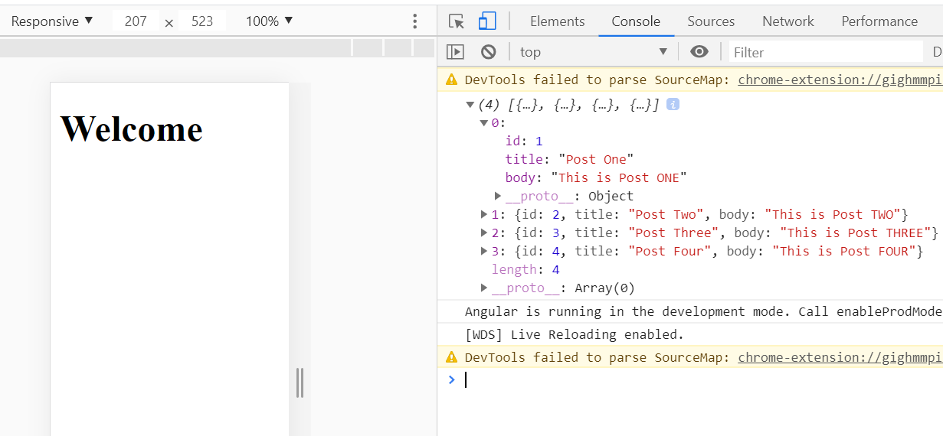

To make the service ***asynchronous***, we apply ***Promises***

Unser folder “services”, create a new file call it Post.ts

export class Post {

    id : number;

    title: string;

    body: string;

. Change the file Post.service to:

import {Injectable} from '@angular/core';

import {Post} from './Post';

@Injectable()

export class PostService{

    getPosts():Promise<Post[]>{

        return Promise.resolve(POSTS);

    }

}

export const POSTS = [

    {id : 1, title: "Post One", body:"This is Post ONE"},

    {id : 2, title: "Post Two", body:"This is Post TWO"},

    {id : 3, title: "Post Three", body:"This is Post THREE"},

    {id : 4, title: "Post Four", body:"This is Post FOUR"}

]

Change app.component.ts

import { Component } from '@angular/core';

import {PostService} from './services/post.service';

import {Post} from './services/Post';

@Component({

  selector: 'app-root',

  template: `<h1>Welcome</h1>

  `,

  providers: [PostService],

  styleUrls: ['./app.component.css']

})

export class AppComponent {

  posts: Post[];

  constructor(private _postService:PostService){

     this._postService.getPosts().then(

        posts => {this.posts = posts}

     );

  }

}

Now, to display all Posts, change the template as:

 template: `<h1>Welcome</h1>

    <ul>

      <li *ngFor="let post of posts">

        <h3>{{post.title}}</h3>

        <p>{{post.body}}</p>

      </li>

    </ul>

  `,

Run the application

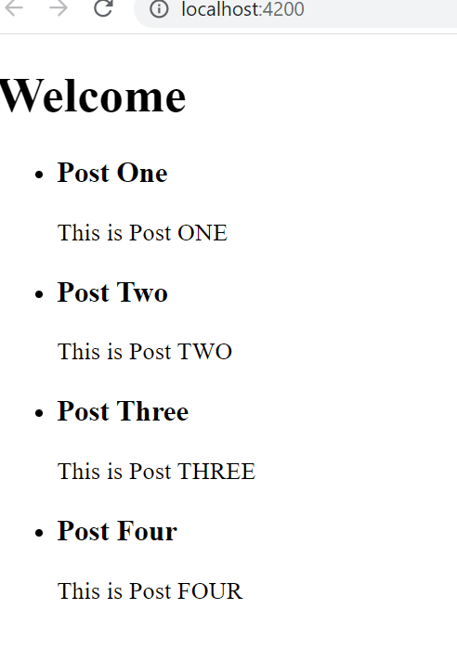

Now, apply the css file:

body{

    background: #6666;

    font-family: arial;

    font-weight: 2em;

    text-align: center;

}

ul{

    list-style: none;

}

li{

    border-bottom: 1px dotted #ccc;

}

.container{

    width: 600px;

    border: solid 1px #ccc;

    margin: auto;

    background: #f4f4f4;

}

Run the app:

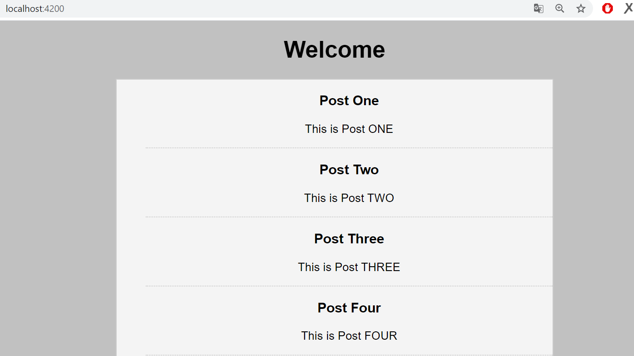

Conclusions

In this exercise you have learnt to set up an online Git repository, synchronize your local repository with the remote repository, and clone an online repository.